Table of Content
1. Introduction 2
2. System Architecture Design 2
2.1. Key Interaction Flow 4
3. Database Design 5
3.1. Database Overview 5
3.2. Entity-Relationship Diagram 6
3.3. Relationship Explanation 7
4. Page Descriptions 8
4.1. Homepage 8
4.2. Menu Page 9
4.3. Food Detail Page 10
4.4. Registration Page 11
4.5. Login Page 12
4.6. Cart Page 13
4.7. Checkout Page 14
4.8. Order Confirmation Page 15
4.9. Order History Page 16
4.10. Admin Dashboard 17
4.11. Admin Food Management Page 18
4.12. Admin Category Management Page 19
4.13. Admin Order Management Page 20
5. Java EE Technologies Used 21
6. Validation and Access Control 21

Introduction
The Food Ordering and Restaurant Management Website is a Java EE web application designed to support both restaurant customers and administrators. The system allows customers to browse food menus, view food details, register or log in, add selected items to a shopping cart, place orders, and view order history. It also provides an admin area for managing food items, food categories, and customer orders.
This system meets the client's needs by combining a customer-facing ordering flow with a restaurant-facing management interface in one web application. Customers can conveniently explore available dishes and complete the ordering process online, while administrators can maintain menu data and monitor customer orders through the admin dashboard.
The main functions of the system include:
- Customers can browse featured and popular dishes, filter menu items by category, inspect ingredients, nutrition, price, ratings, and review counts.
- Registered users can add dishes to the cart, choose quantities and add-ons, submit checkout details, and view order history.
- Administrators can access a dashboard, manage foods and categories, and update order status.
- The system uses JSP, Servlets, JavaBeans, DAO classes, JDBC, and MySQL to provide dynamic page rendering, request handling, session management, and persistent data storage.

System Architecture Design
The application follows a Model-View-Controller (MVC) style structure. JSP pages are used as the view layer to display dynamic web pages and collect user input. Servlets act as the controller layer by receiving HTTP requests, validating form data, controlling page navigation, and forwarding or redirecting users to the correct JSP pages. Model classes such as User, Food, Category, Cart, Order, and OrderItem represent the main domain data used in the system.
For data storage, the system uses an AppStore facade together with DAO classes and JDBC to connect to a MySQL database. The AppStore class provides simple methods for the Servlets, while the DAO classes handle database operations such as creating users, loading food items, saving orders, and updating order status. Session management is used to store the logged-in user and the shopping cart during the browsing and checkout process.
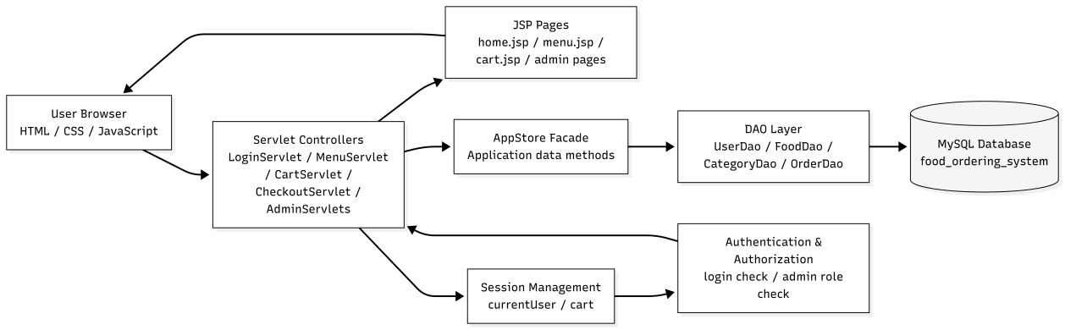
Figure 2.1. System architecture of the Food Ordering System

Table 2.1. Role - Layer Table
Layer | Implementation | Role
Front-end | JSP, HTML, CSS, JavaScript | Renders pages, responsive layout, form validation, menu and cart views.
Controller | Servlets such as LoginServlet, CartServlet, CheckoutServlet, AdminFoodServlet | Receives requests, validates input, updates application state, and forwards/redirects users.
Model | User, Food, Category, Cart, CartItem, Order, OrderItem | Represents application data and business objects.
Data layer | MySQL database with tables users, categories, foods, orders, and order_items | Stores persistent data for accounts, menu items, categories, orders, and order details
Authentication | HttpSession currentUser and role checks | Controls login state and admin-only access.

Key Interaction Flow
This section describes the main interaction flows in the Food Ordering System. The system contains two important flows: the customer order processing flow and the admin management flow. The customer flow focuses on how a user places an order, while the admin flow focuses on how the administrator manages menu data and customer orders.
Figure 2.2. Order processing flow of the Food Ordering System.

Figure 2.2 shows the customer order processing flow of the Food Ordering System. The process starts when the customer browses the menu and views food details. The customer can select a food item, choose the quantity, and select available add-ons. When the customer continues to the cart or checkout process, the system checks whether the user is logged in. If the user is not logged in, the system redirects the user to the login page.
After login, authenticated users can add selected food items to the session-based shopping cart. During checkout, the customer enters the delivery address, contact phone number, and payment method. The system then creates the order, saves the order and order item details into the MySQL database, clears the cart, and displays the order confirmation page with the order ID and final amount.
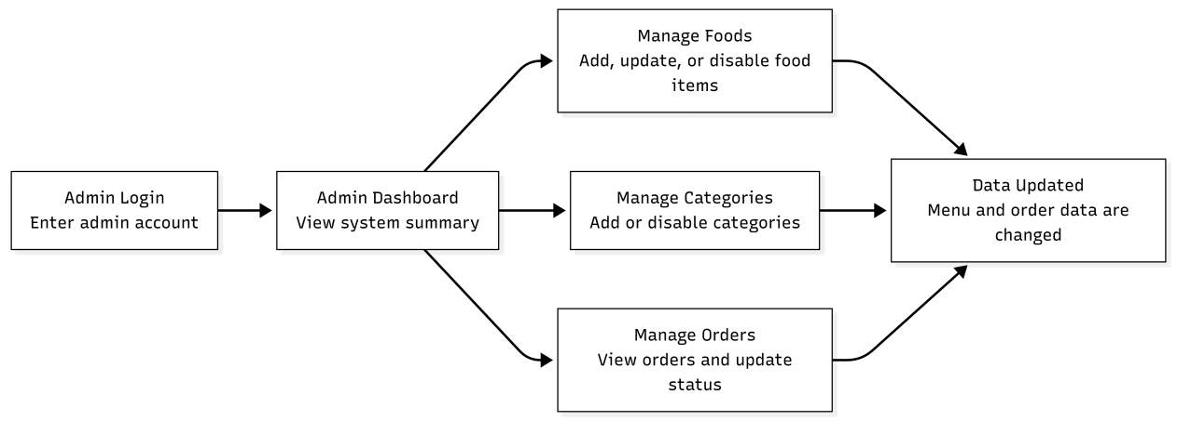
Figure 2.3. Admin management flow of the Food Ordering System.
Figure 2.3 shows the admin management flow. The administrator first logs in using an admin account and enters the admin dashboard. From the dashboard, the administrator can manage food items, manage categories, and view customer orders. Food management includes adding, updating, or disabling food items. Category management allows the administrator to add or disable food categories. Order management allows the administrator to view customer orders and update their status. After these actions are completed, the system data is updated and reflected in the customer-facing pages.

Database Design

Database Overview
The Food Ordering System uses a MySQL database named food_ordering_system to store persistent application data. The database connection settings are configured in src/main/resources/db.properties, including the JDBC URL, database username, password, and MySQL driver. The database schema is defined in database/schema.sql.
The database stores the main data of the website, including user accounts, food categories, menu items, customer orders, and order details. It supports both customer functions and admin functions. Customers can register, log in, browse food items, add items to the cart, and place orders. Admin users can manage food items, manage categories, and view customer orders.
Table 3.1. Database Description Tables
Table | Description
users | Stores user account information, including username, email, phone number, password, role, and account creation time. The role field is used to identify normal users and admin users.
categories | Stores food category information, such as Main Course, Snack, Drink, and Dessert.
foods | Stores food menu item details, including food name, category, description, ingredients, nutrition, price, rating, image, availability, featured status, and popular status.
orders | Stores customer order records, including the user who placed the order, delivery address, contact phone, payment method, order status, payment status, total amount, and order time.
order_items | Stores the food items inside each order, including food ID, food name, unit price, quantity, add-ons, add-on price, and subtotal.

Entity-Relationship Diagram
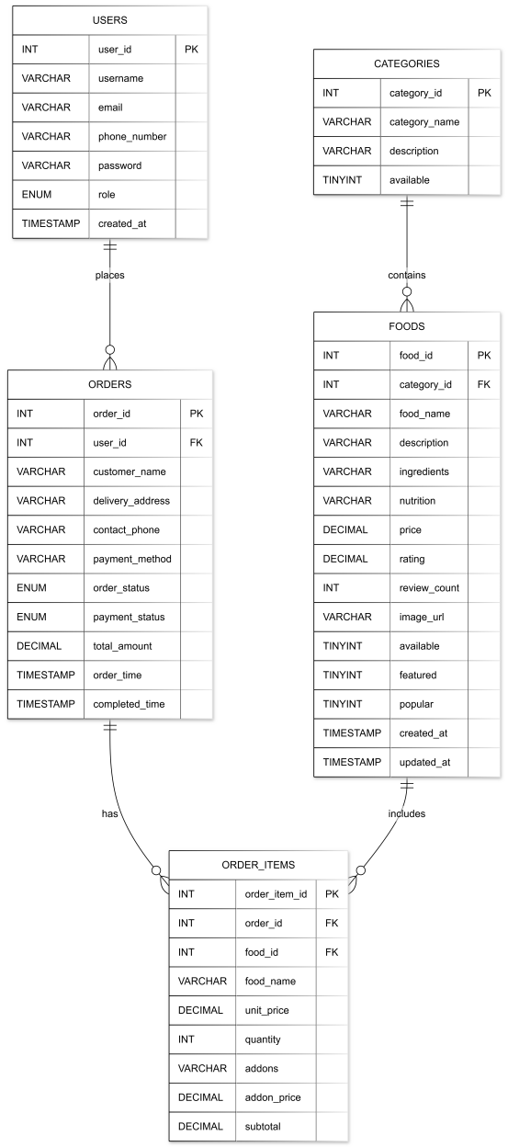
Figure 3.1. Entity-Relationship Diagram of the Food Ordering System

Relationship Explanation
The users table has a one-to-many relationship with the orders table because one user can place many orders. The categories table has a one-to-many relationship with the foods table because one category can contain many food items. The orders table has a one-to-many relationship with the order_items table because one order can include multiple food items. The foods table is linked to the order_items table because each order item refers to one selected food item.
The order_items table also stores the food name, unit price, add-ons, and subtotal as order snapshots. This is useful because the system can keep the original order details even if the food information is changed later by the admin.

Page Descriptions
This section describes the main pages of the Food Ordering and Restaurant Management Website. Each page is designed to support either customer ordering functions or administrator management functions. The customer pages allow users to browse food items, register, log in, manage their cart, place orders, and view order history. The admin pages allow administrators to manage menu data, categories, and customer orders.

Homepage
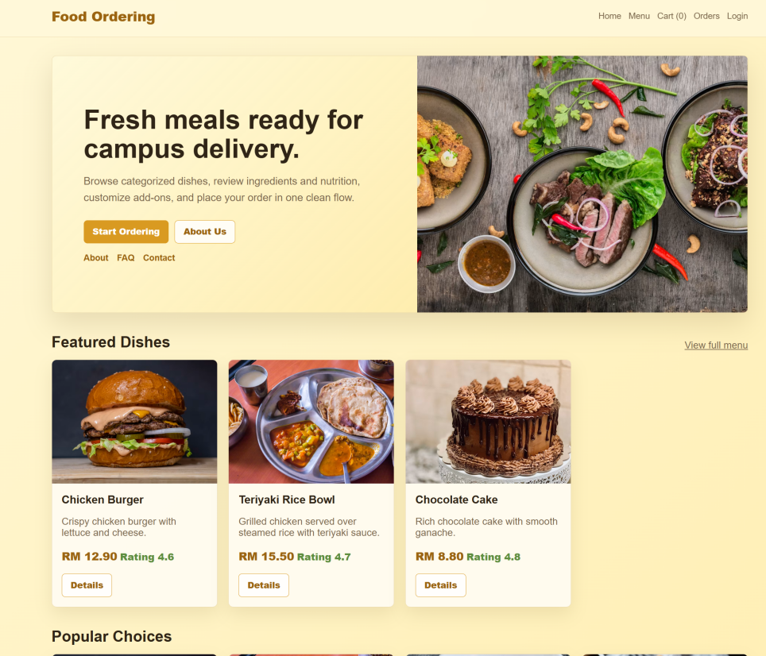
Figure 4.1. Homepage Screenshot
The homepage is the first page users see when they access the system. It introduces the Food Ordering System and provides quick access to the menu page. The homepage displays featured dishes and popular food items to attract users and help them quickly discover available meals. It also includes basic information sections such as About Us, FAQ, and Contact, which make the website feel complete and user-friendly.

Menu Page
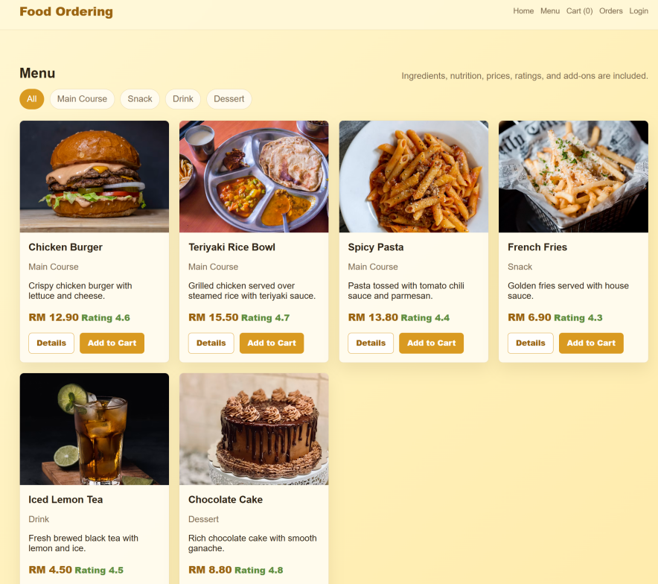
Figure 4.2. Menu Page
The menu page displays the list of available food items. Food items are arranged by category, such as main course, snacks, drinks, and desserts. Each food card shows important information including the food name, image, description, price, and rating. Users can filter food items by category and choose items they want to order. This page helps customers compare dishes before adding them to the cart.

Food Detail Page
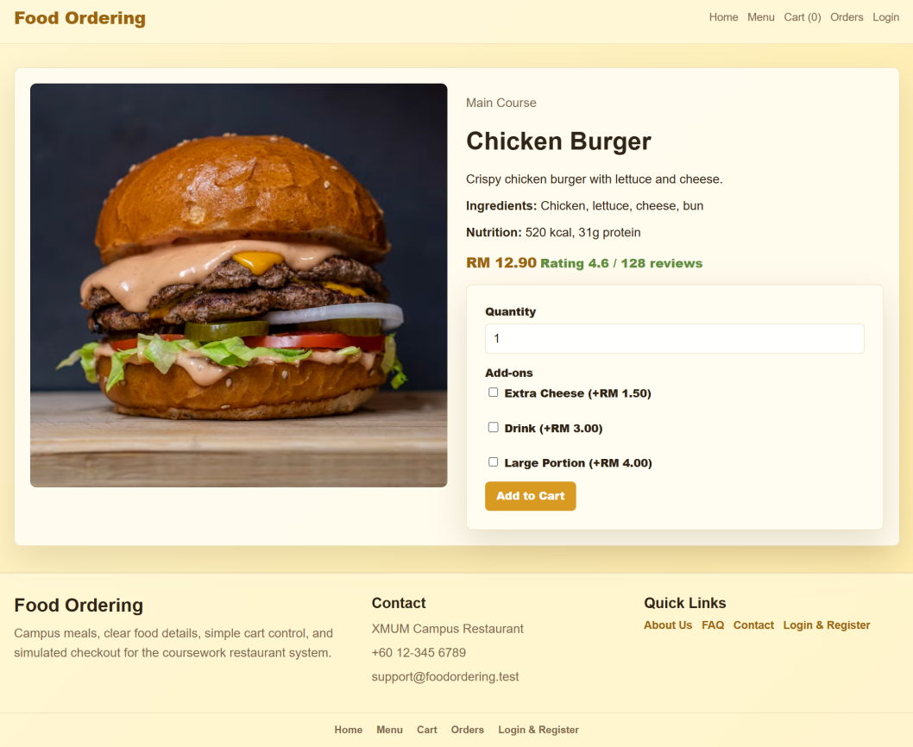
Figure 4.3. Food Detail Page
The food detail page provides more complete information about a selected food item. It shows the food image, category, description, ingredients, nutrition information, price, rating, and review count. Users can also select the quantity and choose add-ons such as extra cheese, drink, or large portion. This page supports better decision-making before the item is added to the cart.

Registration Page
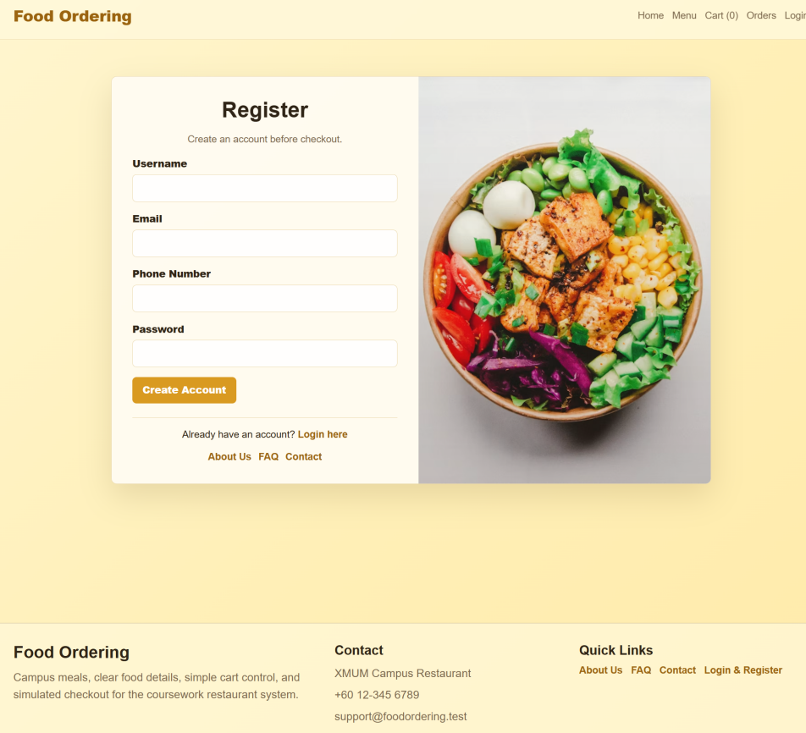
Figure 4.4. Registration Page
The registration page allows new users to create an account. Users need to enter a username, email address, phone number, and password. The system validates the input to make sure the username length is suitable, the email format is correct, the phone number is provided, and the password meets the minimum length requirement. It also checks whether the username or email already exists. After successful registration, the user can log in and start ordering.

Login Page
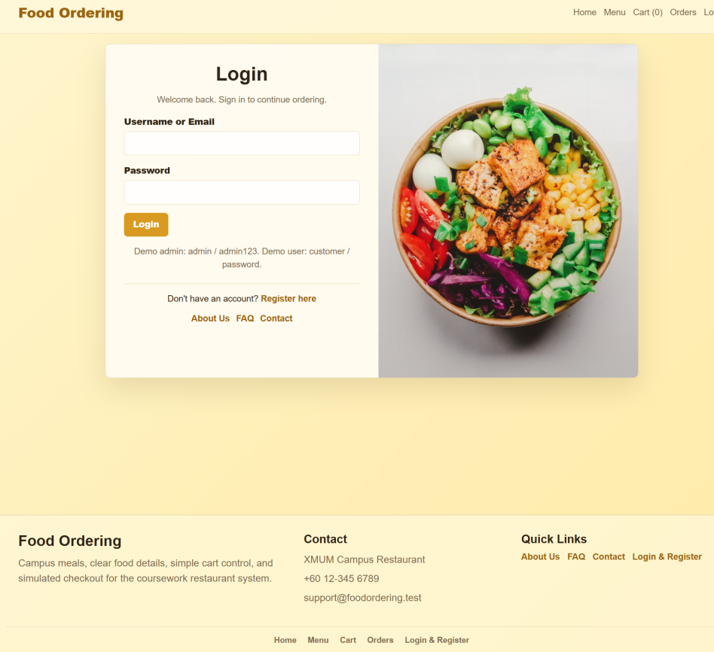
Figure 4.5. Login Page
The login page is used to authenticate existing users. Users can log in using their username or email together with their password. After successful login, normal customers are redirected to the customer homepage, while admin users are redirected to the admin dashboard. The login function also supports session management, so the system can remember the current user during ordering.

Cart Page
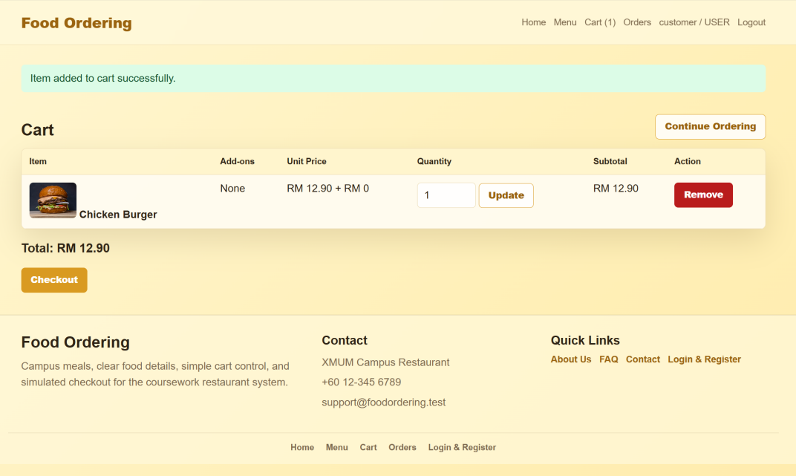
Figure 4.6. Cart Page
The cart page displays all food items selected by the customer. It shows the food name, add-ons, unit price, quantity, subtotal, and total amount. Users can update item quantities or remove items from the cart before checkout. This page gives customers a final chance to review their order and make changes before submitting it.

Checkout Page
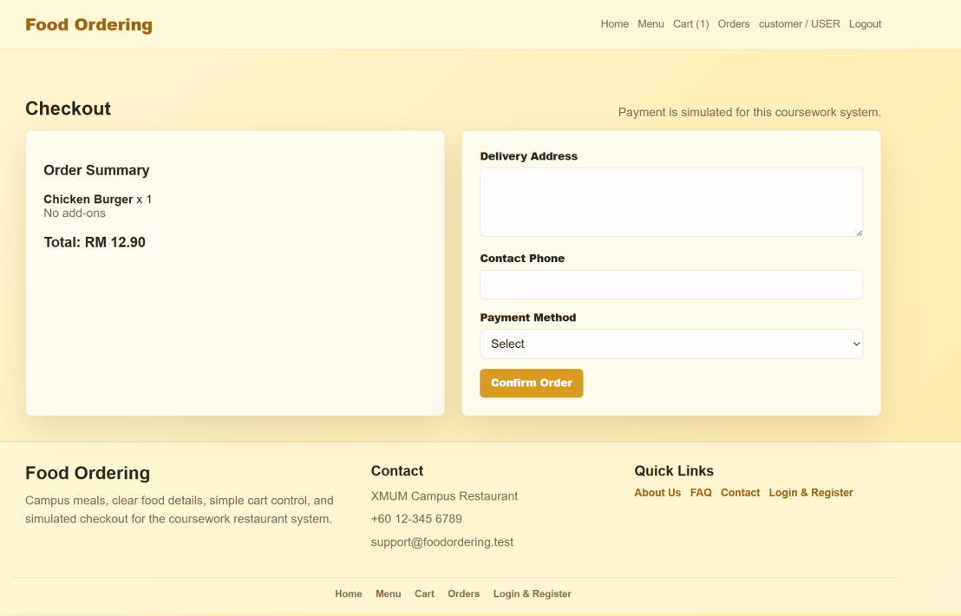
Figure 4.7. Checkout Page
The checkout page allows logged-in users to complete their order. It displays an order summary and requires the customer to enter delivery address, contact phone number, and payment method. The system checks that the cart is not empty and that all required checkout fields are completed. After the form is submitted successfully, the order is created and the cart is cleared.

Order Confirmation Page
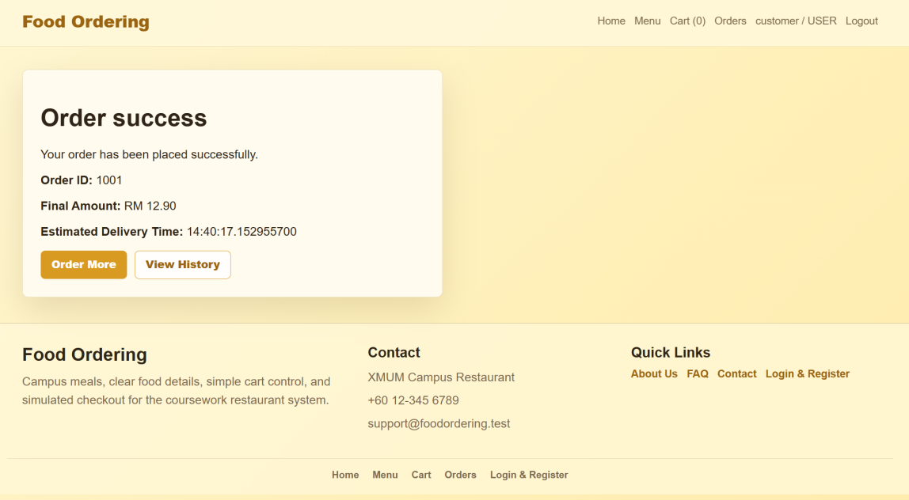
Figure 4.8. Order Confirmation Page
The order confirmation page is displayed after a successful checkout. It shows the order ID, final amount, and estimated delivery time. This page confirms that the order has been received by the system. It improves user confidence by giving clear feedback after the purchase process is completed.

Order History Page
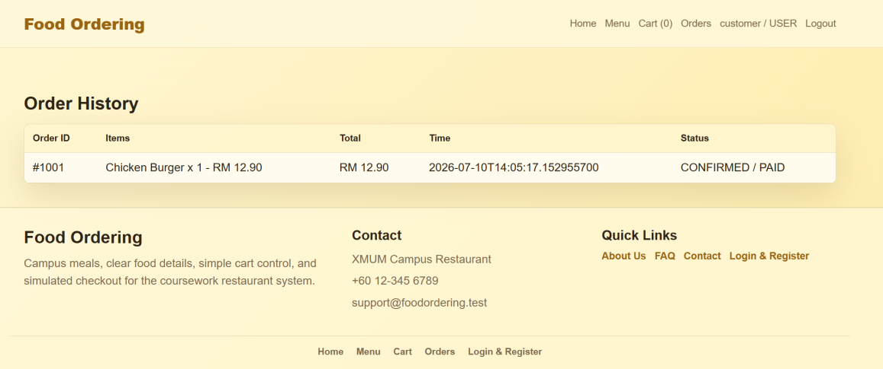
Figure 4.9. Order History Page
The order history page allows customers to view their previous orders. Each order record includes the order ID, ordered items, total amount, order time, order status, and payment status. This page helps users track their past purchases and check whether an order is confirmed, completed, or cancelled.

Admin Dashboard
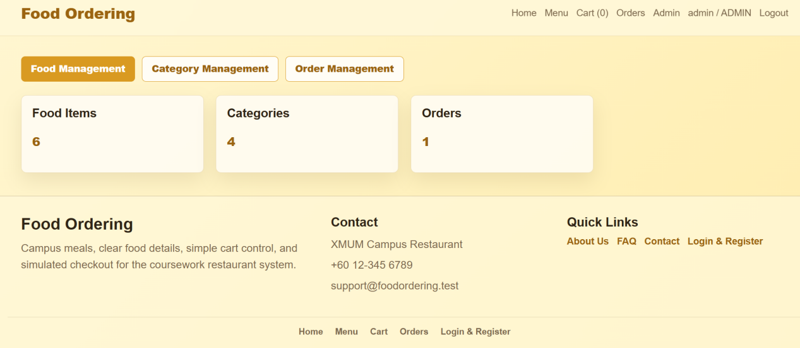
Figure 4.10. Admin Dashboard
The admin dashboard is the main page for administrators after login. It provides a summary of the system, including the number of food items, categories, and orders. It also provides navigation links to food management, category management, and order management pages. This page allows administrators to quickly access the main backend functions.

Admin Food Management Page
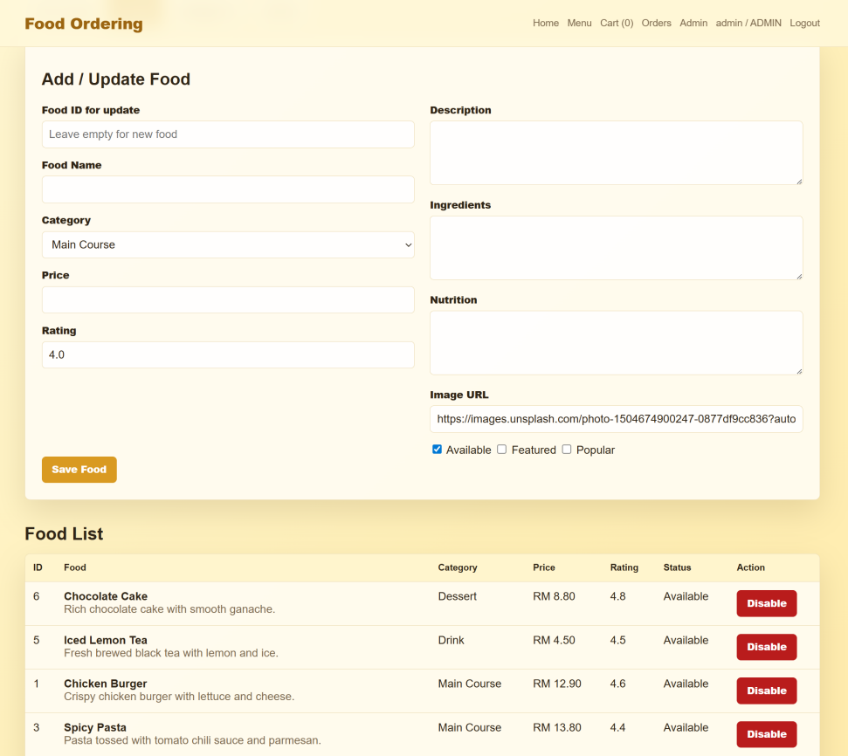
Figure 4.11. Admin Food Management Page
The admin food management page allows administrators to manage menu items. Admins can add new food items or update existing food information such as food name, category, price, rating, description, ingredients, nutrition information, image URL, availability, featured status, and popular status. Admins can also disable food items that are no longer available. This page is important because the customer menu depends on the food data maintained by the administrator.

Admin Category Management Page
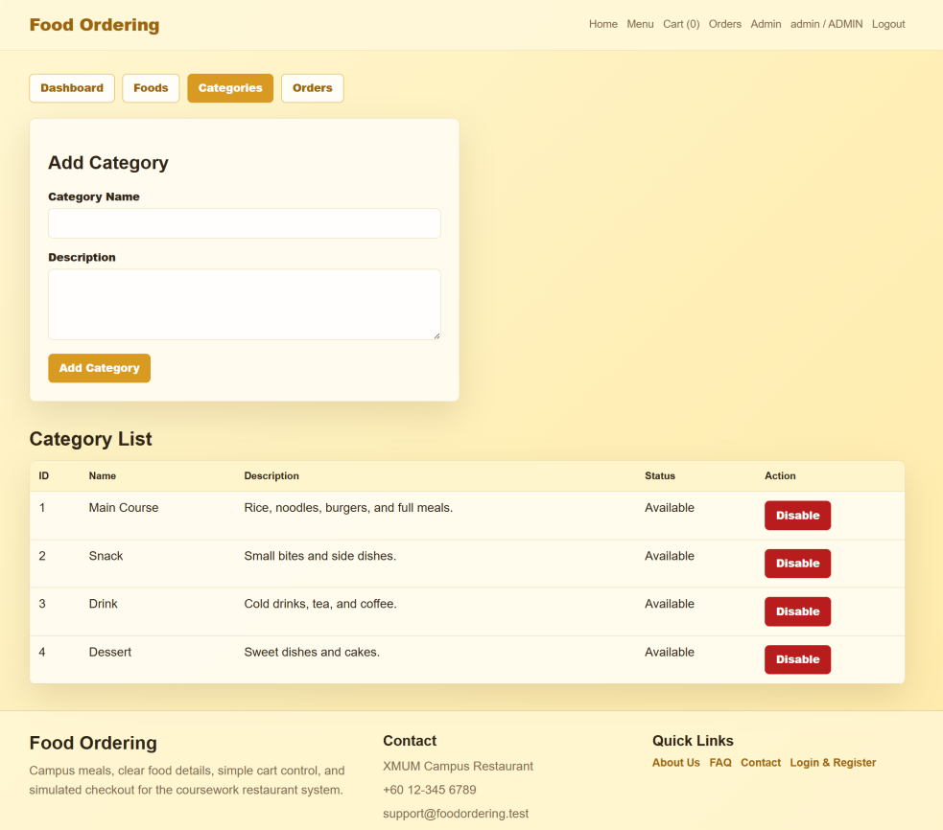
Figure 4.12. Admin Category Management Page
The admin category management page allows administrators to manage food categories. Admins can add new categories by entering a category name and description. They can also disable categories when they are no longer needed. Category management helps organize menu items clearly and makes browsing easier for customers.

Admin Order Management Page
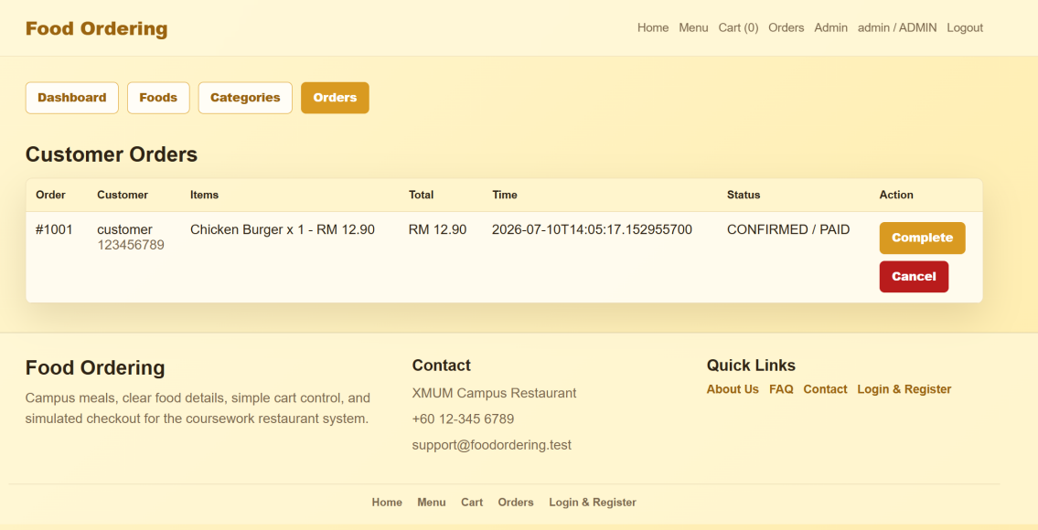
Figure 4.13. Admin Order Management Page
The admin order management page allows administrators to view customer orders. Each order shows the order ID, customer information, ordered items, total amount, order time, order status, and payment status. Administrators can update order status by marking an order as completed or cancelled. This page supports restaurant order handling and helps the admin monitor customer purchases.

Java EE Technologies Used
Table 5.1. Technology – Contribution Table
Technology | Where It Is Used | Contribution
JSP | home.jsp, menu.jsp, cart.jsp, admin pages | Dynamic page rendering using request/session attributes.
Servlets | LoginServlet, RegisterServlet, CartServlet, CheckoutServlet, admin servlets | Request routing, validation, session handling, and business flow control.
JavaBeans / Model Classes | User, Food, Category, Cart, Order, OrderItem | Structured data objects used by controllers and JSP views.
RequestDispatcher | WebUtil.forward() | Forwards requests from Servlets to JSP pages.
HttpSession | currentUser and cart | Maintains login state and shopping cart data.

Validation and Access Control
- Registration validation checks username length, email format, duplicate username/email, phone presence, and password length.
- Login stores the authenticated user in session and redirects admins and customers to the correct area.
- Ordering pages call requireLogin, so guests cannot access cart and checkout actions.
- Admin pages call requireAdmin, so non-admin users cannot manage food, categories, or orders.
- Checkout validates non-empty cart, delivery address, contact phone, and payment method before creating an order.

